

***lab # 03***

*Objective: To understand the complexities of the recursive functions and a way to reduce these complexities.*



October 28, 2024

***LAB TASKS***

***TASK # 01***



*INPUT*

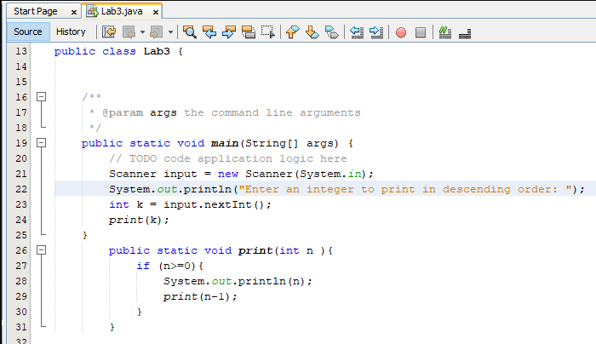

*OUTPUT*

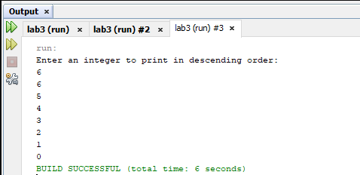

***TASK # 02***



*INPUT*

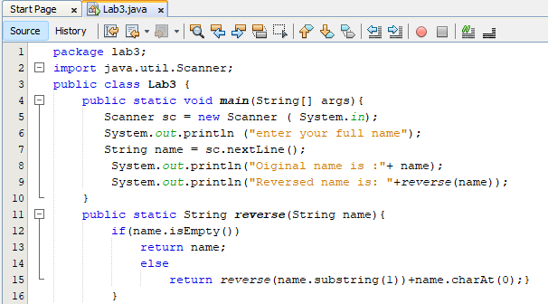

*OUTPUT*

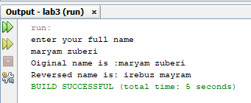

***TASK # 03***

**

*INPUT*

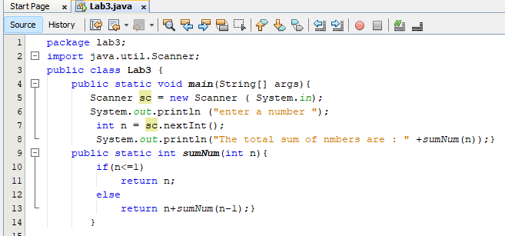

*OUTPUT*

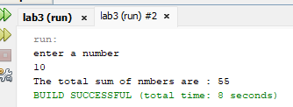

***TASK # 04***

**

*INPUT*

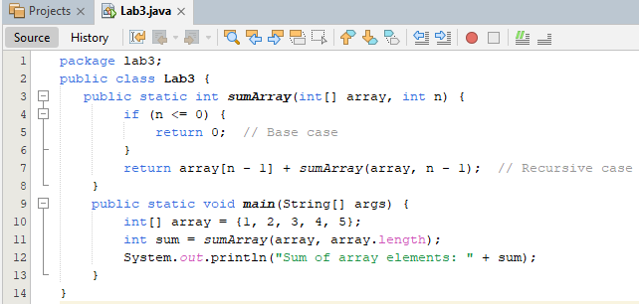

*OUTPUT*

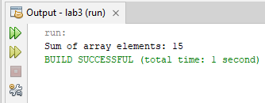

***TASK # 05***

**

*INPUT*

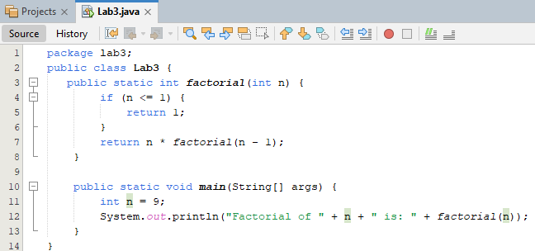

*OUTPUT*

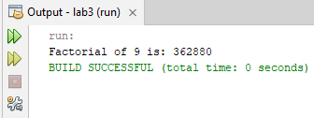

***TASK # 06***



*INPUT*

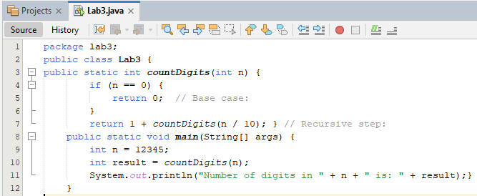

*OUTPUT*

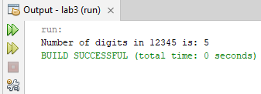

***HOME TASKS***

***TASK # 01***



*INPUT*

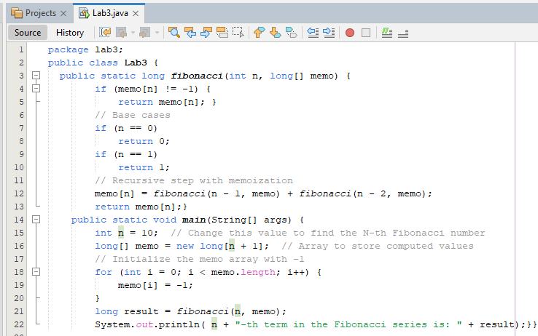

*OUTPUT*

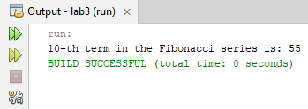

***TASK # 02***



*INPUT*

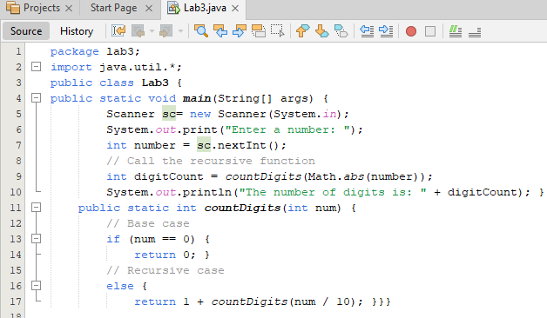

*OUTPUT*

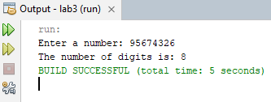

***TASK # 03***

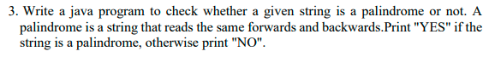

*INPUT*

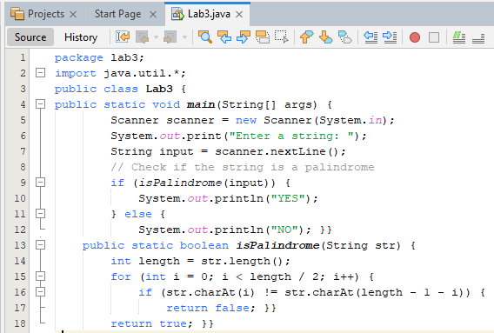

*OUTPUT*

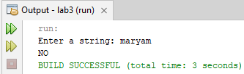

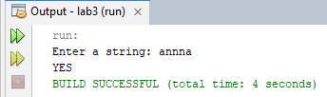

***TASK # 04***



*INPUT*

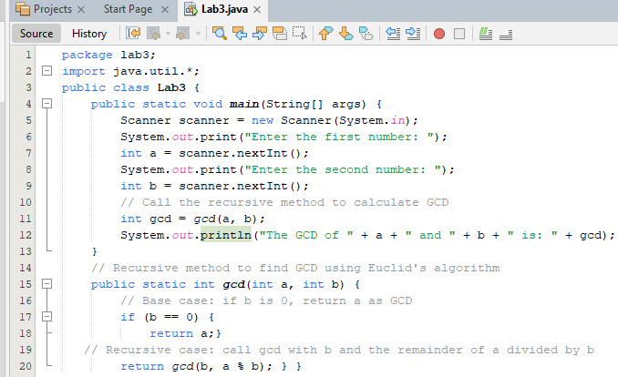

*OUTPUT*

